**Índex**  
  
1. Introduction………………………………………  
  
 1.1.Goals……………………………………….

2. Use Cases

2.1. Use Case Model

3. Use Case Application

**1.Introduction**

1.1 – This document specifies how the E-Lockers system, developed for managing Everis office lockers works.

**2. Use Cases**

**2.1 –** *Use Case Model*

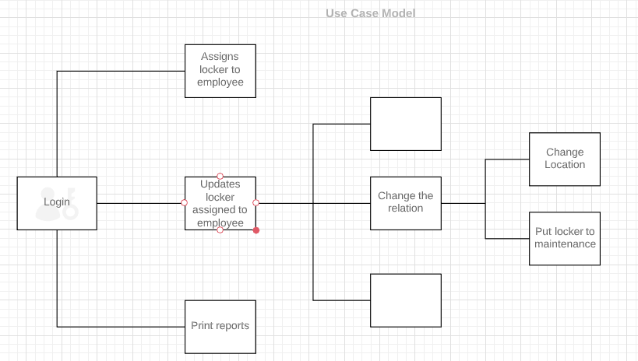

**3. Use Case Application**

1. User inserts the locker number on the field
2. User inserts the employee number on the field
3. User inserts the employee name
4. User inserts the email
5. User press the submit button